EXCHANGE RATES
1.
Pearson Edexcel - Specimen Papers Set 1 - Paper 2 (Calculator) Higher Tier
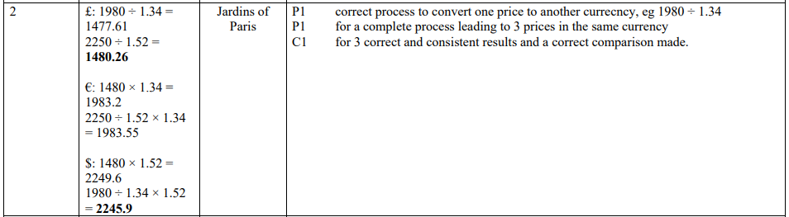
Pearson Edexcel - Sample Paper 3 - (Calculator) Higher Tier
2.
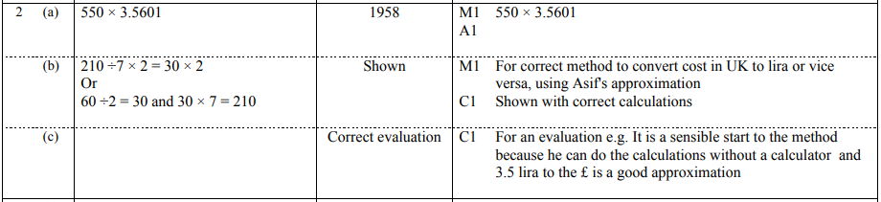
Pearson Edexcel - Friday 7 November 2014 - Paper 2 (Calculator) Higher Tier
3.
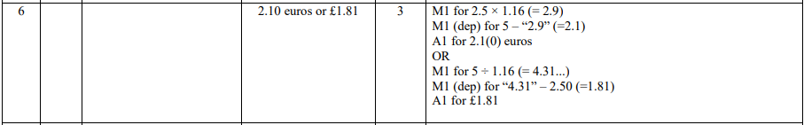
Pearson Edexcel - Friday 8 November 2013 - Paper 2 (Calculator) Higher Tier
4.
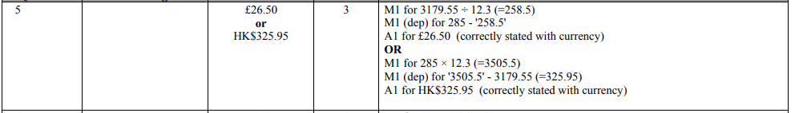

Pearson Edexcel - Thursday 8 November 2012 - Paper 2 (Calculator) Higher Tier
5.
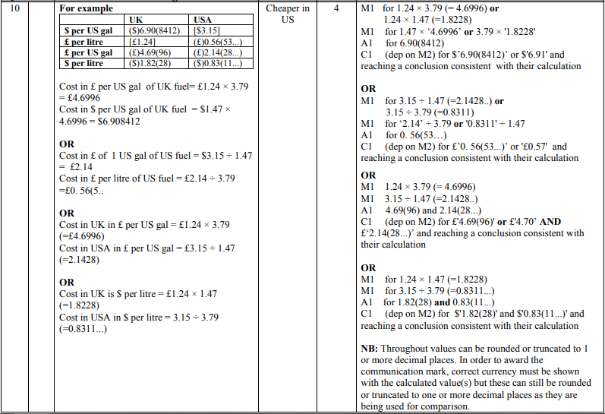
Pearson Edexcel - Wednesday 13 June 2012 - Paper 2 (Calculator) Higher Tier
6.
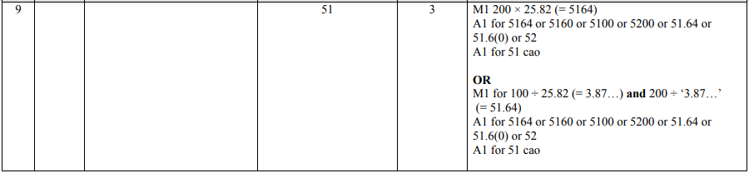
Pearson Edexcel - Monday 5 March 2012 - Paper 4 (Calculator) Higher Tier
7.
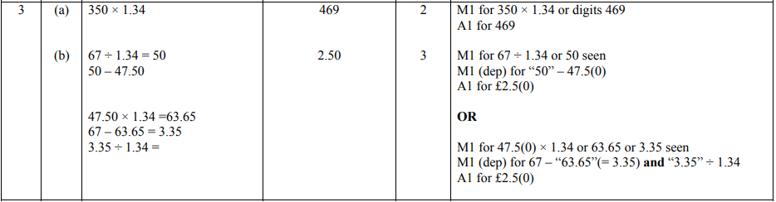
Pearson Edexcel - Monday 14 November 2011 - Paper 4 (Calculator) Higher Tier
8.
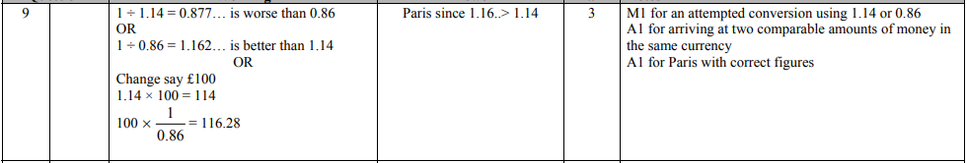
Pearson Edexcel - Friday 11 June 2010 - Paper 4 (Calculator) Higher Tier
9.
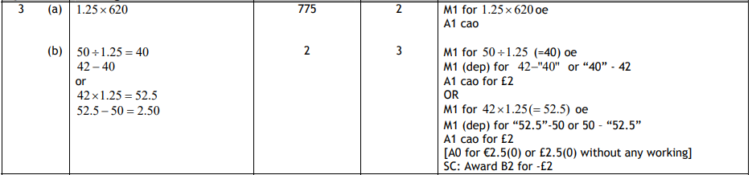
10.

